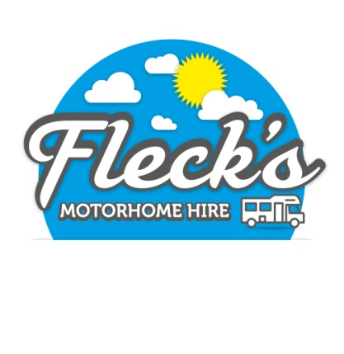

|  |  |  |
| --- | --- | --- |
| 12 Watersheddings Way | www.flecksmotorhomehire.co.uk | |
| Oldham | Email: | fleck_fleck@yahoo.co.uk |
| Greater Manchester | Tel: | 07889 980 502 |
| OL4 2RE |  | |

**Identity Requirements**

It is an insurance requirement that you provide sufficient documentation to support your identity. Without this documentation you will not be insured and therefore unable to hire our Motorhome.

You must provide 1 of the following

* Photographic Driving Licence (It must show the same address as additional documents listed below)
* Paper Driving Licence, but must be accompanied by a valid passport (It must show the same address as additional documents listed below)

You must also provide

* Your National insurance so that a DVLA check can be done. Detailed on the booking form.
* 2 separate Utility bills, as proof of your address. See details below for examples (They must show the same address as above and be dated within 90 days)

Examples of utility bills

The bills need to be in the same name as the driver / hirer and include their home address. Joint names are acceptable, but any in the spouse’s name only are not.

* Gas bill / statement
* Electricity bill / statement
* Water bill / statement
* TV Licence
* Landline telephone bill / statement (mobile phone bill is not acceptable)
* Broadband bill / statement

If you are unable to provide 2 of the above documents in the drivers / hirers name, then at least 1 of the above must be provided along with one of the following

* Loan / finance / Credit agreement or Statement
* Council tax bill
* Bank statement / Savings Account statement
* Credit Card Statement
* Mortgage Statement